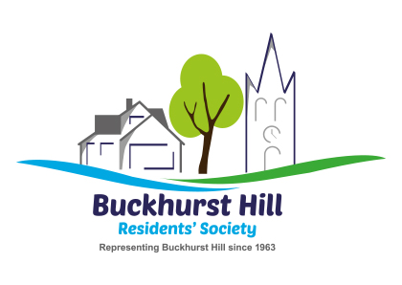

GENERAL DATA PROTECTION REGULATION 2018

New regulations apply from 25 May 2018 governing Data Protection and we need your explicit consent
to store and use your personal data. If you do not complete this form and tick acceptance of the privacy
statement, unfortunately we cannot include you on our database and therefore will not be able to
communicate with you.

Member 1: Title: _______ First Name: __________________ Surname: ____________________________

Member 2: Title: _______ First Name: __________________ Surname: ____________________________

Address: _________________________________________________________Postcode: ______________

Telephone Number: ___________________ email address: ______________________________________

Privacy statement: All personal data supplied on this form will be held and maintained on a secure computer
database for the purposes of administration and distribution of BHRS communications. Your data will never be
supplied to a third party.

You may at any time write to the Society to terminate your membership, in which case the information will be
erased immediately. Should your membership otherwise cease, the information will be erased after two years
have elapsed.

I confirm that I have read and understood the above privacy statement and consent to the use of my personal
data only for the purpose stated above and agree to my email address (if given) being used to receive BHRS
publicity, such as news, meeting reminders etc.

Please tick box to confirm your consent.

Signed: ____________________________

____________________________ Date: ____________

(Where there is joint membership, both members must sign).
____________________________________________________________________________________

Please return this Form to:
Jenn Page, Membership Secretary, 1 Luctons Avenue, Buckhurst Hill, IG9 5SG
or bring to one of our meetings, or to
BHRS c/o Broomes Newsagents, 34 Queens Road, Buckhurst Hill, IG9 5BY

